PRACTICE 4
Determine the validity of the following three statements. Circle either True or False.
1. Group functions work across many rows to produce one result per group.
True/False
2. Group functions include nulls in calculations.
True/False
    - The WHERE clause restricts rows prior to inclusion in a group calculation.
True/False
The HR department needs the following reports:
4. Find the highest, lowest, sum, and average salary of all employees. Label the columns
Maximum, Minimum, Sum, and Average, respectively. Round your results to the nearest whole number. Place your SQL statement in a text file named lab_04_04.sql.
- Modify the query in lab_04_04.sql to display the minimum, maximum, sum, and average salary for each job type. Resave lab_04_04.sql as lab_04_05.sql. Run the statement in lab_04_05.sql.
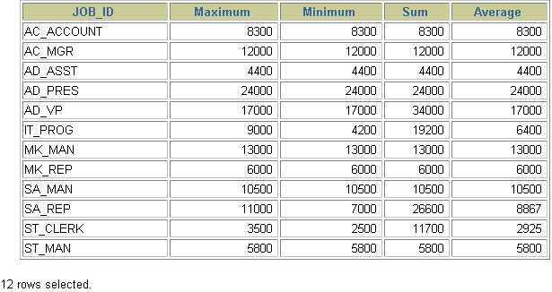
- Write a query to display the number of people with the same job.
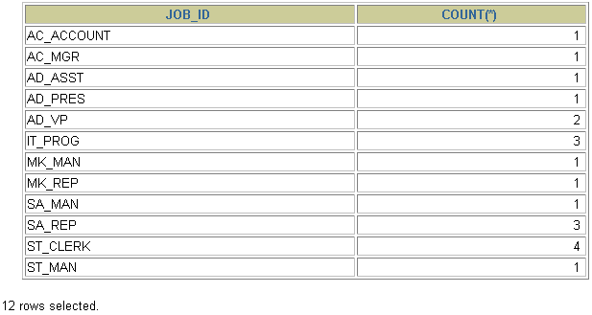
Generalize the query so that the user in the HR department is prompted for a job title. Save the script to a file named lab_04_06.sql.
7. Determine the number of managers without listing them. Label the column Number of Managers. Hint: Use the MANAGER_ID column to determine the number of managers.
8.Find the difference between the highest and lowest salaries. Label the column DIFFERENCE.

